**Optical fibre projects**

***ISEP - Paul JOLIVET (14/10/2024)***

**Principle**

The aim of these projects is to build solutions embedding most of the aspects presented during the course in the typical context of RFP as Infrastructure Operator receive on a regular basis.

**Work basis, expectations**

In the simulation, you are part of the engineering team of ISEP Telecom, a French infrastructure operator. The Program Management team of ISEP-T is expecting from your team a full technical solution for a request that they have (either internal or external to the company). You will be able to use the existing infrastructure of the company and to plan the development of additional infrastructure if needed. From that prospective, the first topic to be addressed by the team is to identify the information to be requested to the transport and backbone engineering team to assess the part of the existing infrastructure that can be used.

The final report is the technical solution on which ISEP-T Program Management team will be able to decide. They will have to present the project to the company Executive Committee. The technical report shall include all details.

**Work organisation**

For those two projects, the teams will need to develop a strategy, and to answer with a calendar for the proposal and an evaluation of the cost for the solution. The price of the service will be left to a separate business unit and will remain apart from the project itself. Both projects take as an assumption that part of the infrastructure is already available.

As part of the work, the teams will have to:

* Identify the information needed from other parts of ISEP-T, that can include for instance
  + technical information on existing infrastructure,
  + geographical inputs,
  + available third-party network (Orange ducts network for instance)
  + information with regards to anchoring sites
* Define the best technical solution with explanations
  + optical fibre type,
  + requested equipment for the infrastructure
  + technical choice for additional deployment when required
* Define the project organisation, including
  + Duration, deadlines,
  + Tasks,
  + Interaction with over ISEP-T departments (commercial, deployment, …)

Some support will be provided for instance when it comes to design geographical shapes of infrastructure and produce maps.

**Agenda**

October, 14th 2024: Project Overview, initial researches

November, 18th 2024: Conception Design Revue

December, 20th 2024: Final Report Delivery

January, 6th 2025: Presentation / Project defence

**Deliverables / Final report**

The expected deliverable is a written report (approximately 10 pages). At least the following points must be treated:

* project organization and management, final tasks table with duration and distribution of the work between the team members,
* system and equipment (details on chosen technology, reasons of the choice…),
* business plan, financial aspects, return on investment,
* engineering rules (details on technical choices, backhaul, capacity, securing backhaul and transport).

In addition, a final presentation will consist in a 20-minute oral presentation by each team, followed by a question/answer session. All the team’s experts must speak during this presentation.

The obtained mark for the presentation will account for 20% of the final mark. The score obtained for the deliveries will account for 40% of the final grade. The project appropriation and its achievement will account for 40% of the final grade.

An individual adjustment on the final mark can be done, depending on the project participation (attendance, participation in the different tasks and their carrying out).

**Project 1: Long haul dark fibre service**

A large American company developing their datacentre activity in France is opening an RFP for long haul connection between their datacentre in Paris (DC1) and their datacentre in Marseille DC2. They request for that line a pair of dark fibre on which they intend to develop their WDM connection. The localisation of the datacentres is provided.

They intend to open service in mid-2024, which implies that the solution shall be as much as possible based on existing infrastructure. Any addition to the infrastructure shall be identified so that it does not affect the deadline.

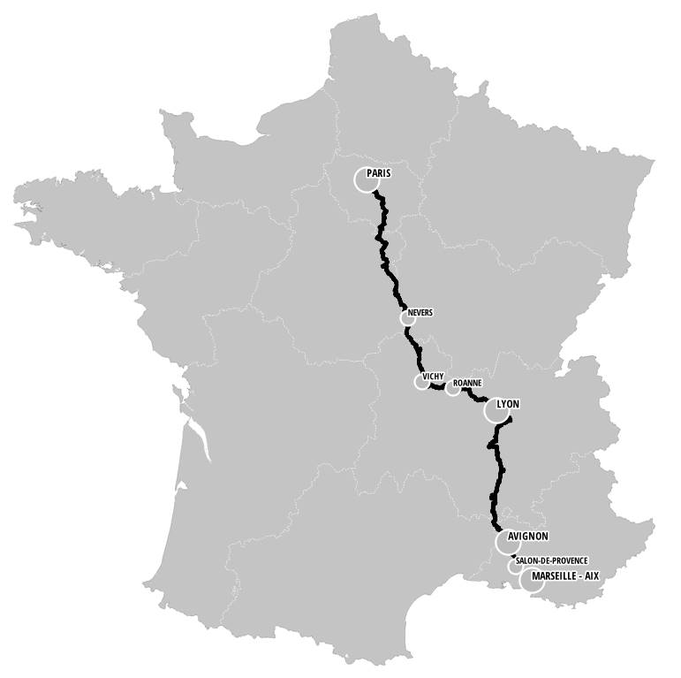

**Project 2: Definition of an FTTA loop for the backhaul of equipment in an urban area**

In the context of the launch of 5G, it has been decided to increase the city coverage to urban areas with over 50k inhabitants. Your team is requested to develop a FTTA backhaul loop for the city of Blois in France.

The equipment to backhaul is listed in the following table:

|  |  |  |
| --- | --- | --- |
| **Type** | **Number** | **Backhaul principles** |
| Radio sites | 17  Green/blue triangle | Secure backhaul by two ways |
| NRA/O (fixed network) | 2  Orange square | Secure backhaul by two ways |
| FTTO/A | (potential) | A fibre |
| Anchoring site | Red square |  |

The following map show the location of equipment, the anchoring site. The black line is the backbone/transportation infrastructure.

You will have to define rules to backhaul equipment in questioning the different teams in the company and identify the technical solution (type of fibre, maximum distance for backhaul…) to justify the solution to be deployed.

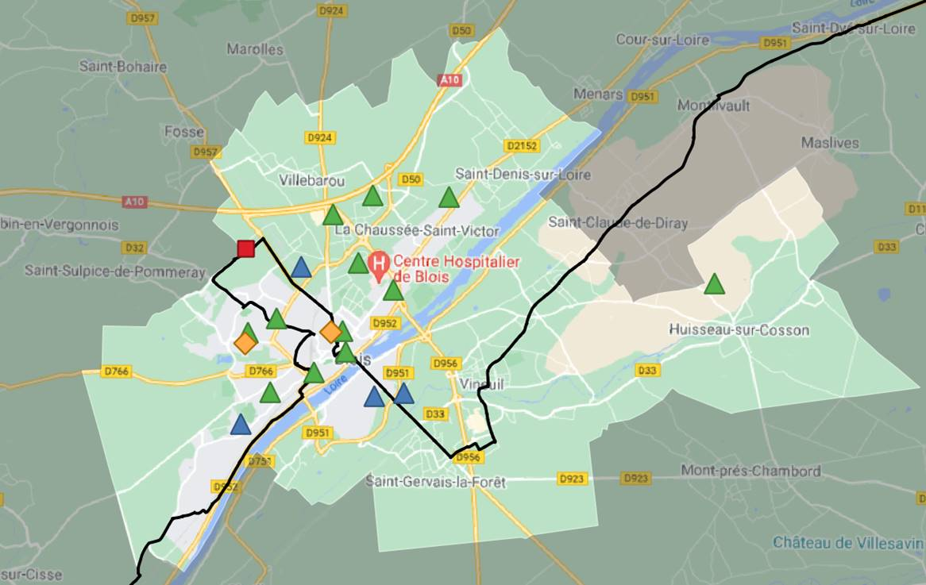

**Project 3: Definition of an FTTA loop for the backhaul of equipment in an urban area**

This project is based on the same principle than Project 2. Your team is requested to develop a FTTA backhaul loop for the city of Lorient in France. The specific data are listed below.

The equipment to backhaul is listed in the following table:

|  |  |  |
| --- | --- | --- |
| **Type** | **Number** | **Backhaul principles** |
| Radio sites | 15  Green/blue triangle | Secure backhaul by two ways |
| NRA/O (fixed network) | 3  Orange square | Secure backhaul by two ways |
| FTTO/A | (potential) | A fibre |
| Anchoring site | Red square |  |

The following map show the location of equipment, the anchoring site. The black line is the backbone/transportation infrastructure.

You will have to define rules to backhaul equipment in questioning the different teams in the company and identify the technical solution (type of fibre, maximum distance for backhaul…) to justify the solution to be deployed.

